MEHRAN UNIVERSITY

OF ENGINEERING & TECHNOLOGY

JAMSHORO, PAKISTAN

To configure the DEFAULT routes between two routers to allow data transfer without the use of dynamic routing protocols.

Subject: COMPUTER NETWORKS (PR)

(Lab 8 - Tasks Solution)

|  |  |
| --- | --- |
| **Roll No:** | **22SW028** |
| **Section:** | **I** |

**LAB TASKS:**

The above network was built using the instructions given in Lab Manual. It is fully functional and uses Default Routing

Answers to the questions given in Lab Manuals are below.

**Answers to Questions:**

**1. How many interfaces are up on Router1? Mention their names.**

Ans: Two interfaces are up on Router1. Their names are Serial0 and Ethernet0.

**2. Are all the necessary interfaces up?**

Ans: Yes, all necessary interfaces on both router 1 and 2 are up

.

**3. What networks are displayed?**

Ans:

R1:

R2:

**4. What interface is directly connected?**

Ans:

On Router1: 192.168.1.0 is directly connected to Ethernet0, and 192.168.0.0 is directly connected to Serial0.

On Router2: 192.168.0.0 is directly connected to Serial0, and 192.168.2.0 is directly connected to Ethernet0.

**5. What does 0.0.0.0 show here?**

Ans: The address 0.0.0.0 is a representation of the default route. It indicates a route that will be used if no other specific route matches the destination IP in the routing table. This address is often called the "gateway of last resort."

**6. List the routes listed in the routing table**

Ans:

R1:

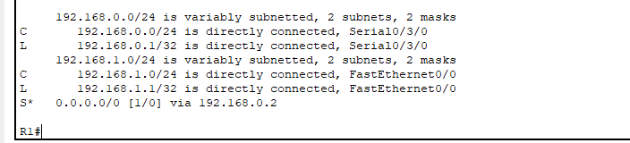

R2:

**7. What is the administrative distance?**

Ans: The administrative distance for a static/default route is 1 because the route is manually configured.

Note: The configuration commands aren’t added in the tasks as they are already present in the manual. The packet tracer file of the following task is also attached with the assignment.

--------------------------------------------THE END-------------------------------------------